Tutorial: Create a Razor Pages web app with ASP.NET Core
Source: https://docs.microsoft.com/en-us/aspnet/core/tutorials/razor-pages
This series of tutorials explains the basics of building a Razor Pages web app. The series includes the following tutorials:
- Create a Razor Pages web app
- Add a model to a Razor Pages app
- Scaffold (generate) Razor pages
- Work with a database
- Update Razor pages
- Add search
- Add a new field
- Add validation
At the end, you'll have an app that can display and manage a database of movies.
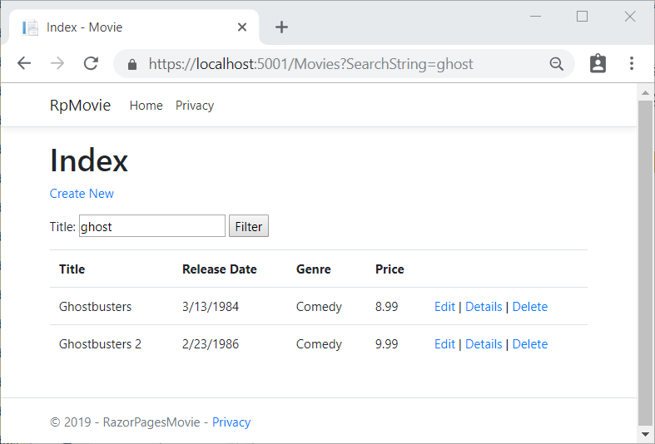

Tutorial: Get started with Razor Pages in ASP.NET Core
This is the first tutorial of a series. The series teaches the basics of building an ASP.NET Core Razor Pages web app. At the end of the series you'll have an app that manages a database of movies.
View or download sample code (how to download).
In this tutorial, you:
- Create a Razor Pages web app.
- Run the app.
- Examine the project files.
At the end of this tutorial you'll have a working Razor Pages web app that you'll build on in later tutorials.
Home or Index page

Prerequisites
- Visual Studio
- Visual Studio 2017 version 15.9 or later with the ASP.NET and web development workload
- .NET Core SDK 2.2 or later
- Visual Studio Code
- Visual Studio Code
- .NET Core SDK 2.2 or later
- C# for Visual Studio Code version 1.17.1 or later

CONTINUE…

Create a Razor Pages web app
- Visual Studio
- From the Visual Studio File menu, select New > Project.
- Create a new ASP.NET Core Web Application. Name the project RazorPagesMovie. It's important to name the project RazorPagesMovie so the namespaces will match when you copy and paste code.
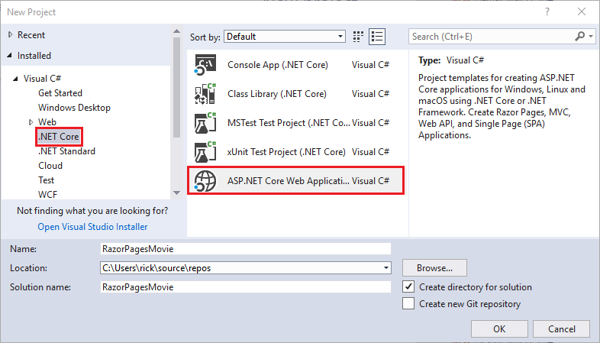
- Select ASP.NET Core 2.2 in the dropdown, and then select Web Application.
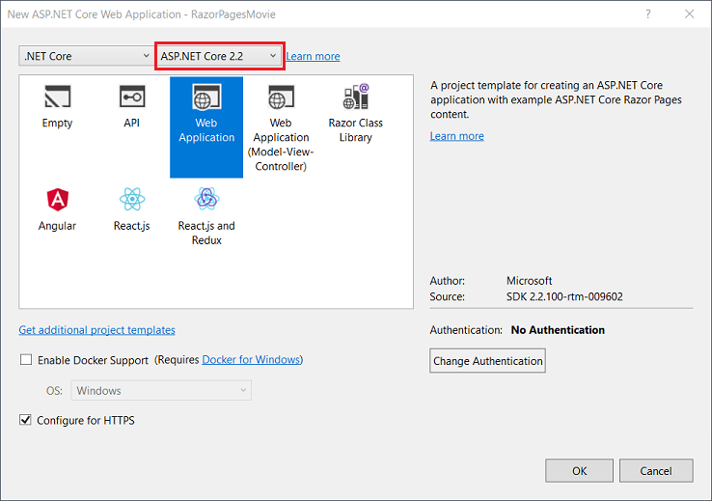
The following starter project is created:
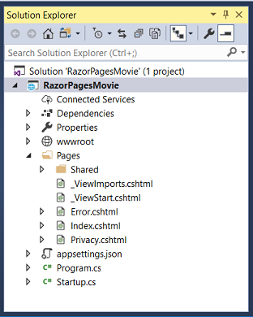

- Visual Studio Code
- Open the integrated terminal.
- Change directories (cd) to a folder which will contain the project.
- Run the following commands:
consoleCopy
dotnet new webapp -o RazorPagesMovie
code -r RazorPagesMovie
  - The dotnet new command creates a new Razor Pages project in the RazorPagesMovie folder.
  - The code command opens the RazorPagesMovie folder in a new instance of Visual Studio Code.
A dialog box appears with Required assets to build and debug are missing from 'RazorPagesMovie'. Add them?
- Select Yes
CONTINUE…

Run the web app
- Visual Studio
- Press Ctrl+F5 to run without the debugger.
Visual Studio starts IIS Express and runs the app. The address bar shows localhost:port# and not something like example.com. That's because localhost is the standard hostname for the local computer. Localhost only serves web requests from the local computer. When Visual Studio creates a web project, a random port is used for the web server. In the preceding image, the port number is 5001. When you run the app, you'll see a different port number.
- Visual Studio Code
- Press Ctrl-F5 to run without the debugger.
- Visual Studio Code starts starts Kestrel, launches a browser, and navigates to http://localhost:5001. The address bar shows localhost:port# and not something like example.com. That's because localhost is the standard hostname for local computer. Localhost only serves web requests from the local computer.

CONTINUE…
- On the app's home page, select Accept to consent to tracking.
This app doesn't track personal information, but the project template includes the consent feature in case you need it to comply with the European Union's General Data Protection Regulation (GDPR).
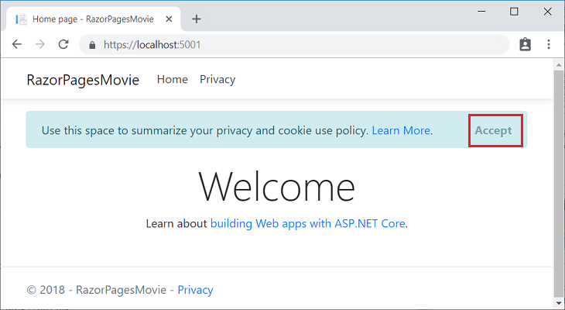
The following image shows the app after you give consent to tracking:
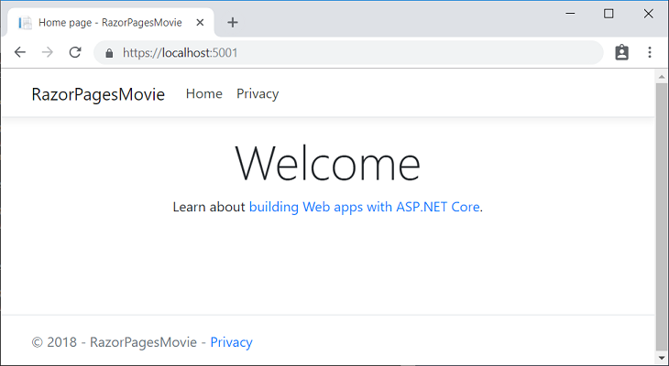

Examine the project files
Here's an overview of the main project folders and files that you'll work with in later tutorials.

Pages folder
Contains Razor pages and supporting files. Each Razor page is a pair of files:
- A .cshtml file that contains HTML markup with C# code using Razor syntax.
- A .cshtml.cs file that contains C# code that handles page events.
Supporting files have names that begin with an underscore. For example, the _Layout.cshtml file configures UI elements common to all pages. This file sets up the navigation menu at the top of the page and the copyright notice at the bottom of the page. For more information, see Layout in ASP.NET Core.

wwwroot folder
Contains static files, such as HTML files, JavaScript files, and CSS files. For more information, see Static files in ASP.NET Core.

appSettings.json
Contains configuration data, such as connection strings. For more information, see Configuration in ASP.NET Core.

Program.cs
Contains the entry point for the program. For more information, see ASP.NET Core Web Host.

Startup.cs
Contains code that configures app behavior, such as whether it requires consent for cookies. For more information, see App startup in ASP.NET Core.

Next steps
In this tutorial, you:
- Created a Razor Pages web app.
- Ran the app.
- Examined the project files.
Advance to the next tutorial in the series:
Add a model

Add a model to a Razor Pages app in ASP.NET Core
View or download sample code (how to download).
In this section, classes are added for managing movies in a database. These classes are used with Entity Framework Core (EF Core) to work with a database. EF Core is an object-relational mapping (ORM) framework that simplifies data access code.
The model classes are known as POCO classes (from "plain-old CLR objects") because they don't have any dependency on EF Core. They define the properties of the data that are stored in the database.
View or download sample.

Add a data model
- Visual Studio
Right-click the RazorPagesMovie project > Add > New Folder. Name the folder Models.
Right click the Models folder. Select Add > Class. Name the class Movie.
Add the following properties to the Movie class:
C#Copy
using System;
using System.ComponentModel.DataAnnotations;

namespace RazorPagesMovie.Models
{
public class Movie
{
public int ID { get; set; }
public string Title { get; set; }

[DataType(DataType.Date)]
public DateTime ReleaseDate { get; set; }
public string Genre { get; set; }
public decimal Price { get; set; }
}
}
The Movie class contains:
- The ID field is required by the database for the primary key.
- [DataType(DataType.Date)]: The DataType attribute specifies the type of the data (Date). With this attribute:
  - The user is not required to enter time information in the date field.
  - Only the date is displayed, not time information.
DataAnnotations are covered in a later tutorial.
- Visual Studio Code
- Add a folder named Models.
- Add a class to the Models folder named Movie.cs.
Add the following properties to the Movie class:
C#Copy
using System;
using System.ComponentModel.DataAnnotations;

namespace RazorPagesMovie.Models
{
public class Movie
{
public int ID { get; set; }
public string Title { get; set; }

[DataType(DataType.Date)]
public DateTime ReleaseDate { get; set; }
public string Genre { get; set; }
public decimal Price { get; set; }
}
}
The Movie class contains:
- The ID field is required by the database for the primary key.
- [DataType(DataType.Date)]: The DataType attribute specifies the type of the data (Date). With this attribute:
  - The user is not required to enter time information in the date field.
  - Only the date is displayed, not time information.
DataAnnotations are covered in a later tutorial.
Add the following RazorPagesMovieContext class to the Models folder:
C#Copy
using Microsoft.EntityFrameworkCore;

namespace RazorPagesMovie.Models
{
public class RazorPagesMovieContext : DbContext
{
public RazorPagesMovieContext (DbContextOptions<RazorPagesMovieContext> options)
: base(options)
{
}

public DbSet<RazorPagesMovie.Models.Movie> Movie { get; set; }
}
}
The preceding code creates a DbSet property for the entity set. In Entity Framework terminology, an entity set typically corresponds to a database table, and an entity corresponds to a row in the table.

Add a database connection string
Add a connection string to the appsettings.json file:
JSONCopy
{
"Logging": {
"LogLevel": {
"Default": "Warning"
}
},
"AllowedHosts": "*",
"ConnectionStrings": {
"MovieContext": "Data Source=MvcMovie.db"
}
}

Add required NuGet packages
Run the following .NET Core CLI command to add SQLite and CodeGeneration.Design to the project:
consoleCopy
dotnet add package Microsoft.EntityFrameworkCore.SQLite
dotnet add package Microsoft.VisualStudio.Web.CodeGeneration.Design
The Microsoft.VisualStudio.Web.CodeGeneration.Design package is required for scaffolding.

Register the database context
Add the following using statements at the top of Startup.cs:
C#Copy
using RazorPagesMovie.Models;
using Microsoft.EntityFrameworkCore;
Register the database context with the dependency injection container in Startup.ConfigureServices.
C#Copy
public void ConfigureServices(IServiceCollection services)
{
services.Configure<CookiePolicyOptions>(options =>
{
// This lambda determines whether user consent for
// non-essential cookies is needed for a given request.
options.CheckConsentNeeded = context => true;
options.MinimumSameSitePolicy = SameSiteMode.None;
});

services.AddDbContext<RazorPagesMovieContext>(options =>
options.UseSqlite(Configuration.GetConnectionString("MovieContext")));

services.AddMvc().SetCompatibilityVersion(CompatibilityVersion.Version_2_2);
}
Build the project as a check for errors.

CONTINUE…
Build the project to verify there are no compilation errors.

Scaffold the movie model
In this section, the movie model is scaffolded. That is, the scaffolding tool produces pages for Create, Read, Update, and Delete (CRUD) operations for the movie model.
- Visual Studio
Create a Pages/Movies folder:
- Right click on the Pages folder > Add > New Folder.
- Name the folder Movies
Right click on the Pages/Movies folder > Add > New Scaffolded Item.
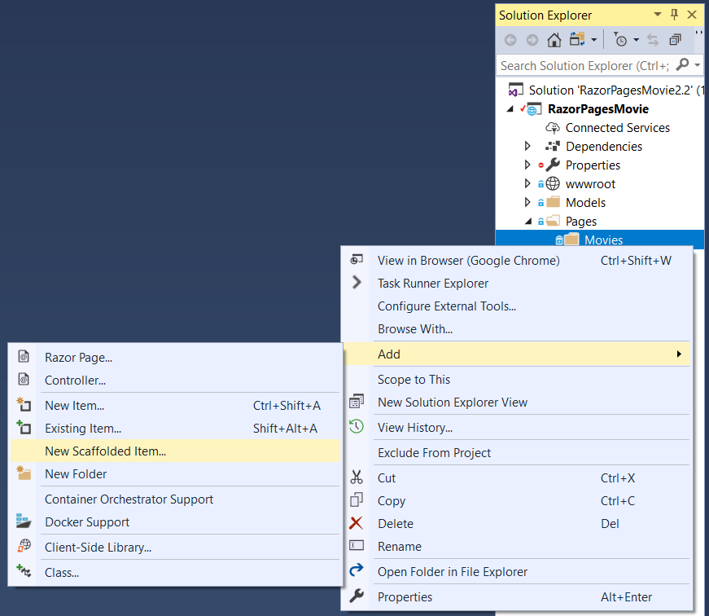
In the Add Scaffold dialog, select Razor Pages using Entity Framework (CRUD) > Add.
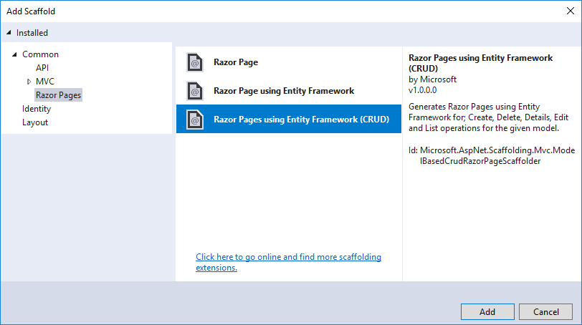
Complete the Add Razor Pages using Entity Framework (CRUD) dialog:
- In the Model class drop down, select Movie (RazorPagesMovie.Models).
- In the Data context class row, select the + (plus) sign and accept the generated name RazorPagesMovie.Models.RazorPagesMovieContext.
- Select Add.
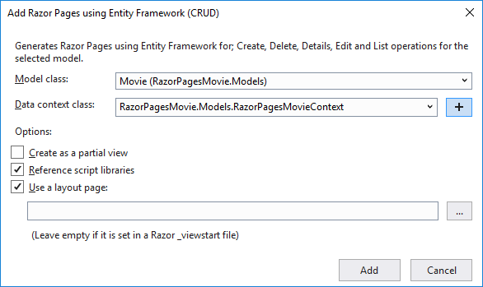
The appsettings.json file is updated with the connection string used to connect to a local database.
- Visual Studio Code
- Open a command window in the project directory (The directory that contains the Program.cs, Startup.cs, and .csproj files).
- Install the scaffolding tool:
consoleCopy
dotnet tool install --global dotnet-aspnet-codegenerator
- For Windows: Run the following command:
consoleCopy
dotnet aspnet-codegenerator razorpage -m Movie -dc RazorPagesMovieContext -udl -outDir Pages\Movies --referenceScriptLibraries
- For macOS and Linux: Run the following command:
consoleCopy
dotnet aspnet-codegenerator razorpage -m Movie -dc RazorPagesMovieContext -udl -outDir Pages/Movies --referenceScriptLibraries
The following table details the ASP.NET Core code generator parameters:
Parameter | Description
-m | The name of the model.
-dc | The DbContext class to use.
-udl | Use the default layout.
-outDir | The relative output folder path to create the views.
--referenceScriptLibraries | Adds _ValidationScriptsPartial to Edit and Create pages
Use the h switch to get help on the aspnet-codegenerator razorpage command:
consoleCopy
dotnet aspnet-codegenerator razorpage -h

CONTINUE…
The scaffold process creates and updates the following files:

Files created
- Pages/Movies: Create, Delete, Details, Edit, and Index.
- Data/RazorPagesMovieContext.cs

File updated
- Startup.cs
The created and updated files are explained in the next section.

Initial migration
- Visual Studio
In this section, the Package Manager Console (PMC) is used to:
- Add an initial migration.
- Update the database with the initial migration.
From the Tools menu, select NuGet Package Manager > Package Manager Console.
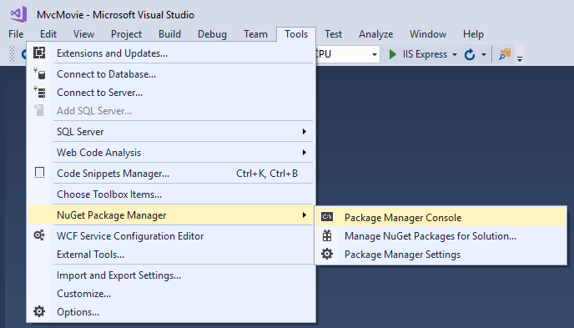
In the PMC, enter the following commands:
PMCCopy
Add-Migration Initial
Update-Database
- Visual Studio Code
- Run the following .NET Core CLI commands:
- consoleCopy
- dotnet ef migrations add InitialCreate
- dotnet ef database update

CONTINUE…
The ef migrations add InitialCreate command generates code to create the initial database schema. The schema is based on the model specified in the DbContext (In the RazorPagesMovieContext.cs file). The InitialCreate argument is used to name the migrations. Any name can be used, but by convention a name is selected that describes the migration.
The ef database update command runs the Up method in the Migrations/<time-stamp>_InitialCreate.cs file. The Up method creates the database.
- Visual Studio

Examine the context registered with dependency injection
ASP.NET Core is built with dependency injection. Services (such as the EF Core DB context) are registered with dependency injection during application startup. Components that require these services (such as Razor Pages) are provided these services via constructor parameters. The constructor code that gets a DB context instance is shown later in the tutorial.
The scaffolding tool automatically created a DB context and registered it with the dependency injection container.
Examine the Startup.ConfigureServices method. The highlighted line was added by the scaffolder:
C#Copy
// This method gets called by the runtime.
// Use this method to add services to the container.
public void ConfigureServices(IServiceCollection services)
{
services.Configure<CookiePolicyOptions>(options =>
{
// This lambda determines whether user consent for non-essential cookies is
// needed for a given request.
options.CheckConsentNeeded = context => true;
options.MinimumSameSitePolicy = SameSiteMode.None;
});

services.AddMvc().SetCompatibilityVersion(CompatibilityVersion.Version_2_2);

services.AddDbContext<RazorPagesMovieContext>(options =>
options.UseSqlServer(
Configuration.GetConnectionString("RazorPagesMovieContext")));
}
The RazorPagesMovieContext coordinates EF Core functionality (Create, Read, Update, Delete, etc.) for the Movie model. The data context (RazorPagesMovieContext) is derived from Microsoft.EntityFrameworkCore.DbContext. The data context specifies which entities are included in the data model.
C#Copy
using Microsoft.EntityFrameworkCore;

namespace RazorPagesMovie.Models
{
public class RazorPagesMovieContext : DbContext
{
public RazorPagesMovieContext (DbContextOptions<RazorPagesMovieContext> options)
: base(options)
{
}

public DbSet<RazorPagesMovie.Models.Movie> Movie { get; set; }
}
}
The preceding code creates a DbSet/<Movie> property for the entity set. In Entity Framework terminology, an entity set typically corresponds to a database table. An entity corresponds to a row in the table.
The name of the connection string is passed in to the context by calling a method on a DbContextOptionsobject. For local development, the ASP.NET Core configuration system reads the connection string from the appsettings.json file.
- Visual Studio Code (N/A)

CONTINUE…
The Add-Migration command generates code to create the initial database schema. The schema is based on the model specified in the RazorPagesMovieContext (In the Data/RazorPagesMovieContext.cs file). The Initialargument is used to name the migrations. Any name can be used, but by convention a name that describes the migration is used. See Introduction to migrations for more information.
The Update-Database command runs the Up method in the Migrations/{time-stamp}_InitialCreate.cs file, which creates the database.

Test the app
- Run the app and append /Movies to the URL in the browser (http://localhost:port/movies).
If you get the error:
consoleCopy
SqlException: Cannot open database "RazorPagesMovieContext-GUID" requested by the login. The login failed.
Login failed for user 'User-name'.
You missed the migrations step.
- Test the Create link.
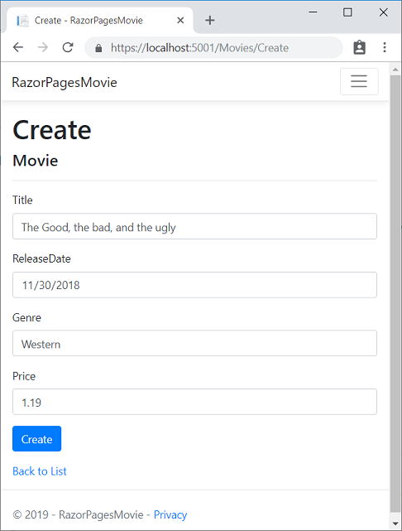
Note
You may not be able to enter decimal commas in the Price field. To support jQuery validation for non-English locales that use a comma (",") for a decimal point and for non US-English date formats, the app must be globalized. For globalization instructions, see this GitHub issue.
- Test the Edit, Details, and Delete links.
The next tutorial explains the files created by scaffolding.

Scaffolded Razor Pages in ASP.NET Core
This tutorial examines the Razor Pages created by scaffolding in the previous tutorial.
View or download sample.

The Create, Delete, Details, and Edit pages
Examine the Pages/Movies/Index.cshtml.cs Page Model:
C#Copy
using System;
using System.Collections.Generic;
using System.Linq;
using System.Threading.Tasks;
using Microsoft.AspNetCore.Mvc;
using Microsoft.AspNetCore.Mvc.RazorPages;
using Microsoft.EntityFrameworkCore;
using RazorPagesMovie.Models;

namespace RazorPagesMovie.Pages.Movies
{
public class IndexModel : PageModel
{
private readonly RazorPagesMovie.Models.RazorPagesMovieContext _context;

public IndexModel(RazorPagesMovie.Models.RazorPagesMovieContext context)
{
_context = context;
}

public IList<Movie> Movie { get;set; }

public async Task OnGetAsync()
{
Movie = await _context.Movie.ToListAsync();
}
}
}
Razor Pages are derived from PageModel. By convention, the PageModel-derived class is called <PageName>Model. The constructor uses dependency injection to add the RazorPagesMovieContext to the page. All the scaffolded pages follow this pattern. See Asynchronous code for more information on asynchronous programing with Entity Framework.
When a request is made for the page, the OnGetAsync method returns a list of movies to the Razor Page. OnGetAsync or OnGet is called on a Razor Page to initialize the state for the page. In this case, OnGetAsyncgets a list of movies and displays them.
When OnGet returns void or OnGetAsync returnsTask, no return method is used. When the return type is IActionResult or Task<IActionResult>, a return statement must be provided. For example, the Pages/Movies/Create.cshtml.cs OnPostAsync method:
C#Copy
public async Task<IActionResult> OnPostAsync()
{
if (!ModelState.IsValid)
{
return Page();
}

_context.Movie.Add(Movie);
await _context.SaveChangesAsync();

return RedirectToPage("./Index");
}
Examine the Pages/Movies/Index.cshtml Razor Page:
CSHTMLCopy
@page
@model RazorPagesMovie.Pages.Movies.IndexModel

@{
ViewData["Title"] = "Index";
}

<h1>Index</h1>

<p>
<a asp-page="Create">Create New</a>
</p>
<table class="table">
<thead>
<tr>
<th>
@Html.DisplayNameFor(model => model.Movie[0].Title)
</th>
<th>
@Html.DisplayNameFor(model => model.Movie[0].ReleaseDate)
</th>
<th>
@Html.DisplayNameFor(model => model.Movie[0].Genre)
</th>
<th>
@Html.DisplayNameFor(model => model.Movie[0].Price)
</th>
<th></th>
</tr>
</thead>
<tbody>
@foreach (var item in Model.Movie) {
<tr>
<td>
@Html.DisplayFor(modelItem => item.Title)
</td>
<td>
@Html.DisplayFor(modelItem => item.ReleaseDate)
</td>
<td>
@Html.DisplayFor(modelItem => item.Genre)
</td>
<td>
@Html.DisplayFor(modelItem => item.Price)
</td>
<td>
<a asp-page="./Edit" asp-route-id="@item.ID">Edit</a> |
<a asp-page="./Details" asp-route-id="@item.ID">Details</a> |
<a asp-page="./Delete" asp-route-id="@item.ID">Delete</a>
</td>
</tr>
}
</tbody>
</table>
Razor can transition from HTML into C# or into Razor-specific markup. When an @ symbol is followed by a Razor reserved keyword, it transitions into Razor-specific markup, otherwise it transitions into C#.
The @page Razor directive makes the file into an MVC action, which means that it can handle requests. @page must be the first Razor directive on a page. @page is an example of transitioning into Razor-specific markup. See Razor syntax for more information.
Examine the lambda expression used in the following HTML Helper:
CSHTMLCopy
@Html.DisplayNameFor(model => model.Movie[0].Title))
The DisplayNameFor HTML Helper inspects the Title property referenced in the lambda expression to determine the display name. The lambda expression is inspected rather than evaluated. That means there is no access violation when model, model.Movie, or model.Movie[0] are null or empty. When the lambda expression is evaluated (for example, with @Html.DisplayFor(modelItem => item.Title)), the model's property values are evaluated.

The @model directive
CSHTMLCopy
@page
@model RazorPagesMovie.Pages.Movies.IndexModel
The @model directive specifies the type of the model passed to the Razor Page. In the preceding example, the @model line makes the PageModel-derived class available to the Razor Page. The model is used in the @Html.DisplayNameFor and @Html.DisplayFor HTML Helpers on the page.

ViewData and layout
Consider the following code from the Pages/Movies/Index.cshtml file:
CSHTMLCopy
@page
@model RazorPagesMovie.Pages.Movies.IndexModel

@{
ViewData["Title"] = "Index";
}
The preceding highlighted code is an example of Razor transitioning into C#. The { and } characters enclose a block of C# code.
The PageModel base class has a ViewData dictionary property that can be used to add data that you want to pass to a View. You add objects into the ViewData dictionary using a key/value pattern. In the preceding sample, the "Title" property is added to the ViewData dictionary.
The "Title" property is used in the Pages/Shared/_Layout.cshtml file. The following markup shows the first few lines of the _Layout.cshtml file.
CSHTMLCopy
<!DOCTYPE html>
<html>
<head>
<meta charset="utf-8" />
<meta name="viewport" content="width=device-width, initial-scale=1.0" />
<title>@ViewData["Title"] - RazorPagesMovie</title>

@*Markup removed for brevity.*@
The line @*Markup removed for brevity.*@ is a Razor comment which doesn't appear in your layout file. Unlike HTML comments (<!-- -->), Razor comments are not sent to the client.

Update the layout
Change the <title> element in the Pages/Shared/_Layout.cshtml file display Movie rather than RazorPagesMovie.
CSHTMLCopy
<!DOCTYPE html>
<html>
<head>
<meta charset="utf-8" />
<meta name="viewport" content="width=device-width, initial-scale=1.0" />
<title>@ViewData["Title"] - Movie</title>
Find the following anchor element in the Pages/Shared/_Layout.cshtml file.
CSHTMLCopy
<a class="navbar-brand" asp-area="" asp-page="/Index">RazorPagesMovie</a>
Replace the preceding element with the following markup.
CSHTMLCopy
<a class="navbar-brand" asp-page="/Movies/Index">RpMovie</a>
The preceding anchor element is a Tag Helper. In this case, it's the Anchor Tag Helper. The asp-page="/Movies/Index" Tag Helper attribute and value creates a link to the /Movies/Index Razor Page. The asp-area attribute value is empty, so the area isn't used in the link. See Areas for more information.
Save your changes, and test the app by clicking on the RpMovie link. See the _Layout.cshtml file in GitHub if you have any problems.
Test the other links (Home, RpMovie, Create, Edit, and Delete). Each page sets the title, which you can see in the browser tab. When you bookmark a page, the title is used for the bookmark. Pages/Index.cshtml and Pages/Movies/Index.cshtml currently have the same title, but you can modify them to have different values.
Note
You may not be able to enter decimal commas in the Price field. To support jQuery validation for non-English locales that use a comma (",") for a decimal point, and non US-English date formats, you must take steps to globalize your app. This GitHub issue 4076 for instructions on adding decimal comma.
The Layout property is set in the Pages/_ViewStart.cshtml file:
CSHTMLCopy
@{
Layout = "_Layout";
}
The preceding markup sets the layout file to Pages/Shared/_Layout.cshtml for all Razor files under the Pagesfolder. See Layout for more information.

The Create page model
Examine the Pages/Movies/Create.cshtml.cs page model:
C#Copy
// Unused usings removed.
using Microsoft.AspNetCore.Mvc;
using Microsoft.AspNetCore.Mvc.RazorPages;
using RazorPagesMovie.Models;
using System;
using System.Threading.Tasks;

namespace RazorPagesMovie.Pages.Movies
{
public class CreateModel : PageModel
{
private readonly RazorPagesMovie.Models.RazorPagesMovieContext _context;

public CreateModel(RazorPagesMovie.Models.RazorPagesMovieContext context)
{
_context = context;
}

public IActionResult OnGet()
{
return Page();
}

[BindProperty]
public Movie Movie { get; set; }

public async Task<IActionResult> OnPostAsync()
{
if (!ModelState.IsValid)
{
return Page();
}

_context.Movie.Add(Movie);
await _context.SaveChangesAsync();

return RedirectToPage("./Index");
}
}
}
The OnGet method initializes any state needed for the page. The Create page doesn't have any state to initialize, so Page is returned. Later in the tutorial you see OnGet method initialize state. The Page method creates a PageResult object that renders the Create.cshtml page.
The Movie property uses the [BindProperty] attribute to opt-in to model binding. When the Create form posts the form values, the ASP.NET Core runtime binds the posted values to the Movie model.
The OnPostAsync method is run when the page posts form data:
C#Copy
public async Task<IActionResult> OnPostAsync()
{
if (!ModelState.IsValid)
{
return Page();
}

_context.Movie.Add(Movie);
await _context.SaveChangesAsync();

return RedirectToPage("./Index");
}
If there are any model errors, the form is redisplayed, along with any form data posted. Most model errors can be caught on the client-side before the form is posted. An example of a model error is posting a value for the date field that cannot be converted to a date. Client-side validation and model validation are discussed later in the tutorial.
If there are no model errors, the data is saved, and the browser is redirected to the Index page.

The Create Razor Page
Examine the Pages/Movies/Create.cshtml Razor Page file:
CSHTMLCopy
@page
@model RazorPagesMovie.Pages.Movies.CreateModel

@{
ViewData["Title"] = "Create";
}

<h1>Create</h1>

<h4>Movie</h4>
<hr />
<div class="row">
<div class="col-md-4">
<form method="post">
<div asp-validation-summary="ModelOnly" class="text-danger"></div>
<div class="form-group">
<label asp-for="Movie.Title" class="control-label"></label>
<input asp-for="Movie.Title" class="form-control" />
<span asp-validation-for="Movie.Title" class="text-danger"></span>
</div>
<div class="form-group">
<label asp-for="Movie.ReleaseDate" class="control-label"></label>
<input asp-for="Movie.ReleaseDate" class="form-control" />
<span asp-validation-for="Movie.ReleaseDate" class="text-danger"></span>
</div>
<div class="form-group">
<label asp-for="Movie.Genre" class="control-label"></label>
<input asp-for="Movie.Genre" class="form-control" />
<span asp-validation-for="Movie.Genre" class="text-danger"></span>
</div>
<div class="form-group">
<label asp-for="Movie.Price" class="control-label"></label>
<input asp-for="Movie.Price" class="form-control" />
<span asp-validation-for="Movie.Price" class="text-danger"></span>
</div>
<div class="form-group">
<input type="submit" value="Create" class="btn btn-primary" />
</div>
</form>
</div>
</div>

<div>
<a asp-page="Index">Back to List</a>
</div>

@section Scripts {
@{await Html.RenderPartialAsync("_ValidationScriptsPartial");}
}
- Visual Studio
Visual Studio displays the <form method="post"> tag in a distinctive bold font used for Tag Helpers:
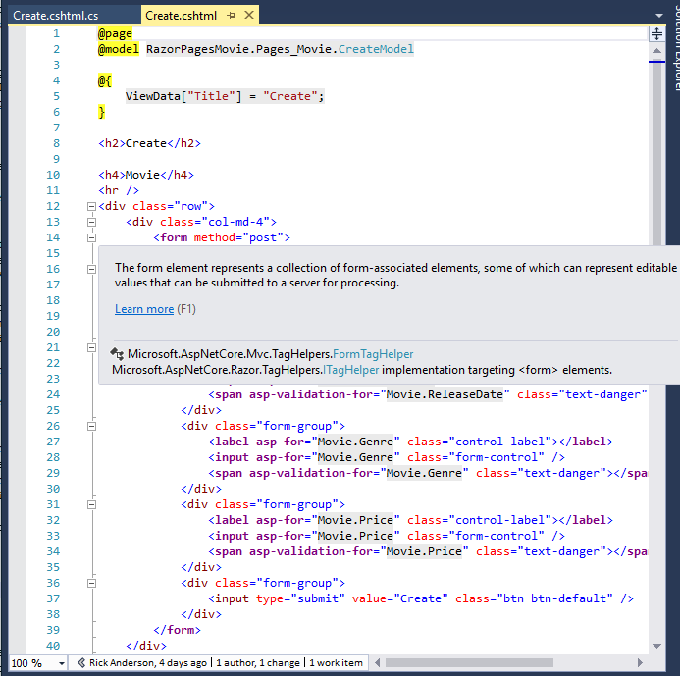
- Visual Studio Code
- For more information on Tag Helpers such as <form method="post">, see Tag Helpers in ASP.NET Core.

CONTINUE…
The <form method="post"> element is a Form Tag Helper. The Form Tag Helper automatically includes an antiforgery token.
The scaffolding engine creates Razor markup for each field in the model (except the ID) similar to the following:
CSHTMLCopy
<div asp-validation-summary="ModelOnly" class="text-danger"></div>
<div class="form-group">
<label asp-for="Movie.Title" class="control-label"></label>
<input asp-for="Movie.Title" class="form-control" />
<span asp-validation-for="Movie.Title" class="text-danger"></span>
</div>
The Validation Tag Helpers (<div asp-validation-summary and <span asp-validation-for) display validation errors. Validation is covered in more detail later in this series.
The Label Tag Helper (<label asp-for="Movie.Title" class="control-label"></label>) generates the label caption and for attribute for the Title property.
The Input Tag Helper (<input asp-for="Movie.Title" class="form-control" />) uses the DataAnnotationsattributes and produces HTML attributes needed for jQuery Validation on the client-side.

Work with a database and ASP.NET Core
View or download sample code (how to download).
The RazorPagesMovieContext object handles the task of connecting to the database and mapping Movieobjects to database records. The database context is registered with the Dependency Injection container in the ConfigureServices method in Startup.cs:
- Visual Studio
C#Copy
// This method gets called by the runtime.
// Use this method to add services to the container.
public void ConfigureServices(IServiceCollection services)
{
services.Configure<CookiePolicyOptions>(options =>
{
// This lambda determines whether user consent for non-essential cookies is
// needed for a given request.
options.CheckConsentNeeded = context => true;
options.MinimumSameSitePolicy = SameSiteMode.None;
});

services.AddMvc().SetCompatibilityVersion(CompatibilityVersion.Version_2_2);

services.AddDbContext<RazorPagesMovieContext>(options =>
options.UseSqlServer(
Configuration.GetConnectionString("RazorPagesMovieContext")));
}
- Visual Studio Code

public void ConfigureServices(IServiceCollection services)
{
services.Configure<CookiePolicyOptions>(options =>
{
// This lambda determines whether user consent for
// non-essential cookies is needed for a given request.
options.CheckConsentNeeded = context => true;
options.MinimumSameSitePolicy = SameSiteMode.None;
});

services.AddDbContext<RazorPagesMovieContext>(options =>
options.UseSqlite(Configuration.GetConnectionString("MovieContext")));

services.AddMvc().SetCompatibilityVersion(CompatibilityVersion.Version_2_2);
}
CONTINUE…
For more information on the methods used in ConfigureServices, see:
- EU General Data Protection Regulation (GDPR) support in ASP.NET Core for CookiePolicyOptions.
- SetCompatibilityVersion
The ASP.NET Core Configuration system reads the ConnectionString. For local development, it gets the connection string from the appsettings.json file.
- Visual Studio
The name value for the database (Database={Database name}) will be different for your generated code. The name value is arbitrary.
JSONCopy
{
"Logging": {
"LogLevel": {
"Default": "Warning"
}
},
"AllowedHosts": "*",
"ConnectionStrings": {
"RazorPagesMovieContext": "Server=(localdb)\\mssqllocaldb;Database=RazorPagesMovieContext-1234;Trusted_Connection=True;MultipleActiveResultSets=true"
}
}

- Visual Studio Code

{
"Logging": {
"LogLevel": {
"Default": "Warning"
}
},
"AllowedHosts": "*",
"ConnectionStrings": {
"MovieContext": "Data Source=MvcMovie.db"
}
}
CONTINUE…
When the app is deployed to a test or production server, an environment variable can be used to set the connection string to a real database server. See Configuration for more information.
- Visual Studio

SQL Server Express LocalDB
LocalDB is a lightweight version of the SQL Server Express database engine that's targeted for program development. LocalDB starts on demand and runs in user mode, so there's no complex configuration. By default, LocalDB database creates *.mdf files in the C:/Users/<user/> directory.
- From the View menu, open SQL Server Object Explorer (SSOX).
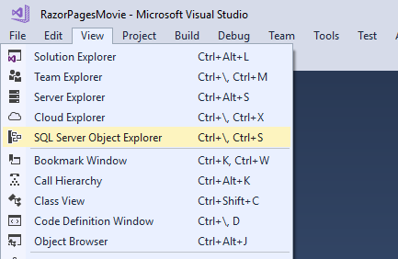
- Right click on the Movie table and select View Designer:
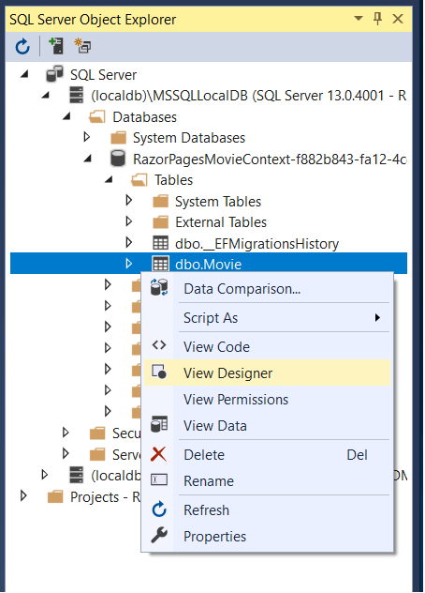
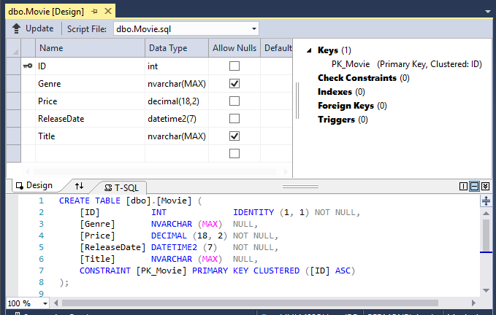
Note the key icon next to ID. By default, EF creates a property named ID for the primary key.
- Right click on the Movie table and select View Data:
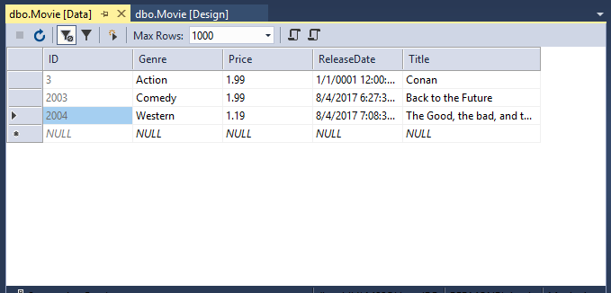

- Visual Studio Code

SQLite
The SQLite website states:
SQLite is a self-contained, high-reliability, embedded, full-featured, public-domain, SQL database engine. SQLite is the most used database engine in the world.
There are many third party tools you can download to manage and view a SQLite database. The image below is from DB Browser for SQLite.

CONTINUE…

Seed the database
Create a new class named SeedData in the Models folder with the following code:
C#Copy
using Microsoft.EntityFrameworkCore;
using Microsoft.Extensions.DependencyInjection;
using System;
using System.Linq;

namespace RazorPagesMovie.Models
{
public static class SeedData
{
public static void Initialize(IServiceProvider serviceProvider)
{
using (var context = new RazorPagesMovieContext(
serviceProvider.GetRequiredService<
DbContextOptions<RazorPagesMovieContext>>()))
{
// Look for any movies.
if (context.Movie.Any())
{
return; // DB has been seeded
}

context.Movie.AddRange(
new Movie
{
Title = "When Harry Met Sally",
ReleaseDate = DateTime.Parse("1989-2-12"),
Genre = "Romantic Comedy",
Price = 7.99M
},

new Movie
{
Title = "Ghostbusters ",
ReleaseDate = DateTime.Parse("1984-3-13"),
Genre = "Comedy",
Price = 8.99M
},

new Movie
{
Title = "Ghostbusters 2",
ReleaseDate = DateTime.Parse("1986-2-23"),
Genre = "Comedy",
Price = 9.99M
},

new Movie
{
Title = "Rio Bravo",
ReleaseDate = DateTime.Parse("1959-4-15"),
Genre = "Western",
Price = 3.99M
}
);
context.SaveChanges();
}
}
}
}
If there are any movies in the DB, the seed initializer returns and no movies are added.
C#Copy
if (context.Movie.Any())
{
return; // DB has been seeded.
}

Add the seed initializer
In Program.cs, modify the Main method to do the following:
- Get a DB context instance from the dependency injection container.
- Call the seed method, passing to it the context.
- Dispose the context when the seed method completes.
The following code shows the updated Program.cs file.
C#Copy
using Microsoft.AspNetCore;
using Microsoft.AspNetCore.Hosting;
using Microsoft.Extensions.DependencyInjection;
using Microsoft.Extensions.Logging;
using RazorPagesMovie.Models;
using System;
using Microsoft.EntityFrameworkCore;

namespace RazorPagesMovie
{
public class Program
{
public static void Main(string[] args)
{
var host = CreateWebHostBuilder(args).Build();

using (var scope = host.Services.CreateScope())
{
var services = scope.ServiceProvider;

try
{
var context=services.
GetRequiredService<RazorPagesMovieContext>();
context.Database.Migrate();
SeedData.Initialize(services);
}
catch (Exception ex)
{
var logger = services.GetRequiredService<ILogger<Program>>();
logger.LogError(ex, "An error occurred seeding the DB.");
}
}

host.Run();
}

public static IWebHostBuilder CreateWebHostBuilder(string[] args) =>
WebHost.CreateDefaultBuilder(args)
.UseStartup<Startup>();
}
}
A production app would not call Database.Migrate. It's added to the preceding code to prevent the following exception when Update-Database has not been run:
SqlException: Cannot open database "RazorPagesMovieContext-21" requested by the login. The login failed. Login failed for user 'user name'.

Test the app
- Visual Studio
- Delete all the records in the DB. You can do this with the delete links in the browser or from SSOX
- Force the app to initialize (call the methods in the Startup class) so the seed method runs. To force initialization, IIS Express must be stopped and restarted. You can do this with any of the following approaches:
  - Right click the IIS Express system tray icon in the notification area and tap Exit or Stop Site:
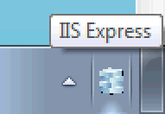
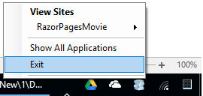
    - If you were running VS in non-debug mode, press F5 to run in debug mode.
    - If you were running VS in debug mode, stop the debugger and press F5.

- Visual Studio Code

Delete all the records in the DB (So the seed method will run). Stop and start the app to seed the database.
The app shows the seeded data.
CONTINUE…
The app shows the seeded data:
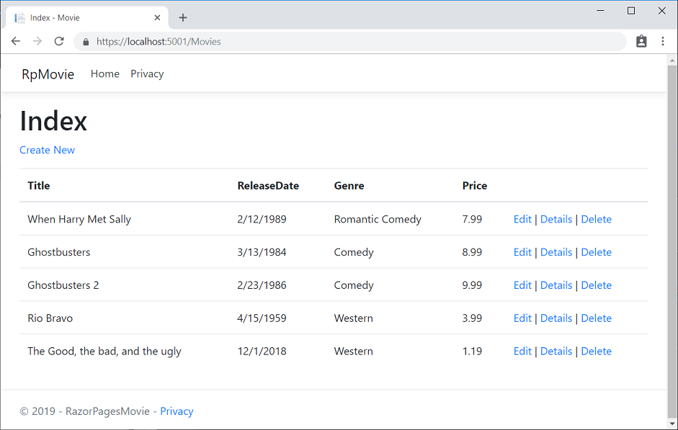
The next tutorial will clean up the presentation of the data.

Update the generated pages in an ASP.NET Core app
The scaffolded movie app has a good start, but the presentation isn't ideal. ReleaseDate should be Release Date (two words).

Update the generated code
Open the Models/Movie.cs file and add the highlighted lines shown in the following code:
C#Copy
using System;
using System.ComponentModel.DataAnnotations;
using System.ComponentModel.DataAnnotations.Schema;

namespace RazorPagesMovie.Models
{
public class Movie
{
public int ID { get; set; }
public string Title { get; set; }

[Display(Name = "Release Date")]
[DataType(DataType.Date)]
public DateTime ReleaseDate { get; set; }
public string Genre { get; set; }

[Column(TypeName = "decimal(18, 2)")]
public decimal Price { get; set; }
}
}
The [Column(TypeName = "decimal(18, 2)")] data annotation enables Entity Framework Core to correctly map Price to currency in the database. For more information, see Data Types.
DataAnnotations is covered in the next tutorial. The Display attribute specifies what to display for the name of a field (in this case "Release Date" instead of "ReleaseDate"). The DataType attribute specifies the type of the data (Date), so the time information stored in the field isn't displayed.
Browse to Pages/Movies and hover over an Edit link to see the target URL.
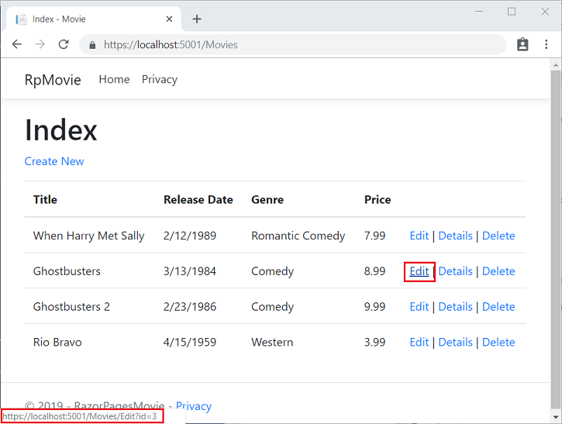
The Edit, Details, and Delete links are generated by the Anchor Tag Helper in the Pages/Movies/Index.cshtmlfile.
CSHTMLCopy
@foreach (var item in Model.Movie) {
<tr>
<td>
@Html.DisplayFor(modelItem => item.Title)
</td>
<td>
@Html.DisplayFor(modelItem => item.ReleaseDate)
</td>
<td>
@Html.DisplayFor(modelItem => item.Genre)
</td>
<td>
@Html.DisplayFor(modelItem => item.Price)
</td>
<td>
<a asp-page="./Edit" asp-route-id="@item.ID">Edit</a> |
<a asp-page="./Details" asp-route-id="@item.ID">Details</a> |
<a asp-page="./Delete" asp-route-id="@item.ID">Delete</a>
</td>
</tr>
}
</tbody>
</table>
Tag Helpers enable server-side code to participate in creating and rendering HTML elements in Razor files. In the preceding code, the AnchorTagHelper dynamically generates the HTML href attribute value from the Razor Page (the route is relative), the asp-page, and the route id (asp-route-id). See URL generation for Pages for more information.
Use View Source from your favorite browser to examine the generated markup. A portion of the generated HTML is shown below:
HTMLCopy
<td>
<a href="/Movies/Edit?id=1">Edit</a> |
<a href="/Movies/Details?id=1">Details</a> |
<a href="/Movies/Delete?id=1">Delete</a>
</td>
The dynamically-generated links pass the movie ID with a query string (for example, the ?id=1 inhttps://localhost:5001/Movies/Details?id=1).
Update the Edit, Details, and Delete Razor Pages to use the "{id:int}" route template. Change the page directive for each of these pages from @page to @page "{id:int}". Run the app and then view source. The generated HTML adds the ID to the path portion of the URL:
HTMLCopy
<td>
<a href="/Movies/Edit/1">Edit</a> |
<a href="/Movies/Details/1">Details</a> |
<a href="/Movies/Delete/1">Delete</a>
</td>
A request to the page with the "{id:int}" route template that does not include the integer will return an HTTP 404 (not found) error. For example, http://localhost:5000/Movies/Details will return a 404 error. To make the ID optional, append ? to the route constraint:
CSHTMLCopy
@page "{id:int?}"
To test the behavior of @page "{id:int?}":
- Set the page directive in Pages/Movies/Details.cshtml to @page "{id:int?}".
- Set a break point in public async Task<IActionResult> OnGetAsync(int? id) (in Pages/Movies/Details.cshtml.cs).
- Navigate to https://localhost:5001/Movies/Details/.
With the @page "{id:int}" directive, the break point is never hit. The routing engine return HTTP 404. Using @page "{id:int?}", the OnGetAsync method returns NotFound (HTTP 404).
Although not recommended, you could write the OnGetAsync method (in Pages/Movies/Delete.cshtml.cs) as:
C#Copy
public async Task<IActionResult> OnGetAsync(int? id)
{
if (id == null)
{
Movie = await _context.Movie.FirstOrDefaultAsync();
}
else
{
Movie = await _context.Movie.FirstOrDefaultAsync(m => m.ID == id);
}

if (Movie == null)
{
return NotFound();
}
return Page();
}
Test the preceding code:
- Select a Delete link.
- Remove the ID from the URL. For example, change https://localhost:5001/Movies/Delete/8 to https://localhost:5001/Movies/Delete.
- Step through the code in the debugger.

Review concurrency exception handling
Review the OnPostAsync method in the Pages/Movies/Edit.cshtml.cs file:
C#Copy

public async Task<IActionResult> OnPostAsync()
{
if (!ModelState.IsValid)
{
return Page();
}

_context.Attach(Movie).State = EntityState.Modified;

try
{
await _context.SaveChangesAsync();
}
catch (DbUpdateConcurrencyException)
{
if (!MovieExists(Movie.ID))
{
return NotFound();
}
else
{
throw;
}
}

return RedirectToPage("./Index");
}

private bool MovieExists(int id)
{
return _context.Movie.Any(e => e.ID == id);
}
The previous code detects concurrency exceptions when the one client deletes the movie and the other client posts changes to the movie.
To test the catch block:
- Set a breakpoint on catch (DbUpdateConcurrencyException)
- Select Edit for a movie, make changes, but don't enter Save.
- In another browser window, select the Delete link for the same movie, and then delete the movie.
- In the previous browser window, post changes to the movie.
Production code may want to detect concurrency conflicts. See Handle concurrency conflicts for more information.

Posting and binding review
Examine the Pages/Movies/Edit.cshtml.cs file:
C#Copy
public class EditModel : PageModel
{
private readonly RazorPagesMovieContext _context;

public EditModel(RazorPagesMovieContext context)
{
_context = context;
}

[BindProperty]
public Movie Movie { get; set; }

public async Task<IActionResult> OnGetAsync(int? id)
{
if (id == null)
{
return NotFound();
}

Movie = await _context.Movie.SingleOrDefaultAsync(m => m.ID == id);

if (Movie == null)
{
return NotFound();
}
return Page();
}

public async Task<IActionResult> OnPostAsync()
{
if (!ModelState.IsValid)
{
return Page();
}

_context.Attach(Movie).State = EntityState.Modified;

try
{
await _context.SaveChangesAsync();
}
catch (DbUpdateConcurrencyException)
{
if (!_context.Movie.Any(e => e.ID == Movie.ID))
{
return NotFound();
}
else
{
throw;
}
}

return RedirectToPage("./Index");
}
}
When an HTTP GET request is made to the Movies/Edit page (for example, http://localhost:5000/Movies/Edit/2):
- The OnGetAsync method fetches the movie from the database and returns the Page method.
- The Page method renders the Pages/Movies/Edit.cshtml Razor Page. The Pages/Movies/Edit.cshtml file contains the model directive (@model RazorPagesMovie.Pages.Movies.EditModel), which makes the movie model available on the page.
- The Edit form is displayed with the values from the movie.
When the Movies/Edit page is posted:
- The form values on the page are bound to the Movie property. The [BindProperty] attribute enables Model binding.
C#Copy
[BindProperty]
public Movie Movie { get; set; }
- If there are errors in the model state (for example, ReleaseDate cannot be converted to a date), the form is displayed with the submitted values.
- If there are no model errors, the movie is saved.
The HTTP GET methods in the Index, Create, and Delete Razor pages follow a similar pattern. The HTTP POST OnPostAsync method in the Create Razor Page follows a similar pattern to the OnPostAsync method in the Edit Razor Page.
Search is added in the next tutorial.

Add search to ASP.NET Core Razor Pages
View or download sample code (how to download).
In the following sections, searching movies by genre or name is added.
Add the following highlighted properties to Pages/Movies/Index.cshtml.cs:
C#Copy
public class IndexModel : PageModel
{
private readonly RazorPagesMovie.Models.RazorPagesMovieContext _context;

public IndexModel(RazorPagesMovie.Models.RazorPagesMovieContext context)
{
_context = context;
}

public IList<Movie> Movie { get; set; }
[BindProperty(SupportsGet = true)]
public string SearchString { get; set; }
// Requires using Microsoft.AspNetCore.Mvc.Rendering;
public SelectList Genres { get; set; }
[BindProperty(SupportsGet = true)]
public string MovieGenre { get; set; }
- SearchString: contains the text users enter in the search text box. SearchString is decorated with the [BindProperty] attribute. [BindProperty] binds form values and query strings with the same name as the property. (SupportsGet = true) is required for binding on GET requests.
- Genres: contains the list of genres. Genres allows the user to select a genre from the list. SelectList requires using Microsoft.AspNetCore.Mvc.Rendering;
- MovieGenre: contains the specific genre the user selects (for example, "Western").
- Genres and MovieGenre are used later in this tutorial.
Warning
For security reasons, you must opt in to binding GET request data to page model properties. Verify user input before mapping it to properties. Opting in to GET binding is useful when addressing scenarios which rely on query string or route values.
To bind a property on GET requests, set the [BindProperty] attribute's SupportsGet property to true: [BindProperty(SupportsGet = true)]
Update the Index page's OnGetAsync method with the following code:
C#Copy
public async Task OnGetAsync()
{
var movies = from m in _context.Movie
select m;
if (!string.IsNullOrEmpty(SearchString))
{
movies = movies.Where(s => s.Title.Contains(SearchString));
}

Movie = await movies.ToListAsync();
}
The first line of the OnGetAsync method creates a LINQ query to select the movies:
C#Copy
// using System.Linq;
var movies = from m in _context.Movie
select m;
The query is only defined at this point, it has not been run against the database.
If the SearchString property is not null or empty, the movies query is modified to filter on the search string:
C#Copy
if (!string.IsNullOrEmpty(SearchString))
{
movies = movies.Where(s => s.Title.Contains(SearchString));
}
The s => s.Title.Contains() code is a Lambda Expression. Lambdas are used in method-based LINQ queries as arguments to standard query operator methods such as the Where method or Contains (used in the preceding code). LINQ queries are not executed when they're defined or when they're modified by calling a method (such as Where, Contains or OrderBy). Rather, query execution is deferred. That means the evaluation of an expression is delayed until its realized value is iterated over or the ToListAsync method is called. See Query Execution for more information.
Note: The Contains method is run on the database, not in the C# code. The case sensitivity on the query depends on the database and the collation. On SQL Server, Contains maps to SQL LIKE, which is case insensitive. In SQLite, with the default collation, it's case sensitive.
Navigate to the Movies page and append a query string such as ?searchString=Ghost to the URL (for example, https://localhost:5001/Movies?searchString=Ghost). The filtered movies are displayed.
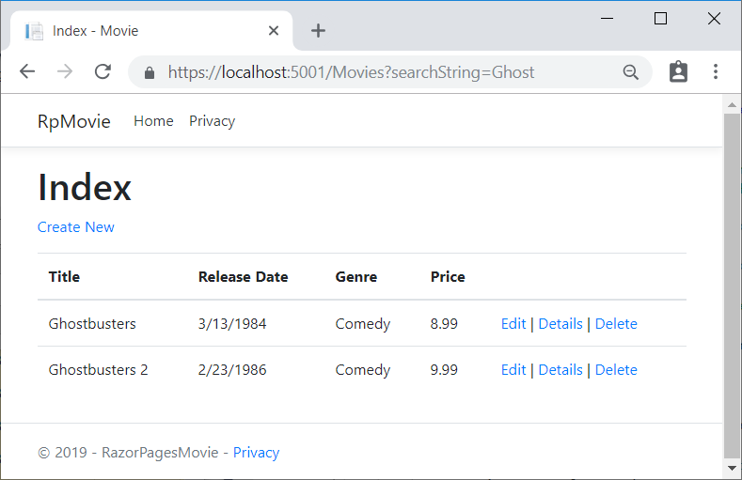
If the following route template is added to the Index page, the search string can be passed as a URL segment (for example, https://localhost:5001/Movies/Ghost).
CSHTMLCopy
@page "{searchString?}"
The preceding route constraint allows searching the title as route data (a URL segment) instead of as a query string value. The ? in "{searchString?}" means this is an optional route parameter.
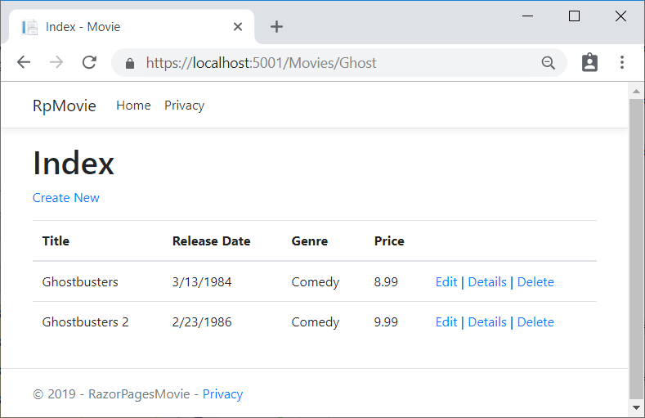
The ASP.NET Core runtime uses model binding to set the value of the SearchString property from the query string (?searchString=Ghost) or route data (https://localhost:5001/Movies/Ghost). Model binding is not case sensitive.
However, you can't expect users to modify the URL to search for a movie. In this step, UI is added to filter movies. If you added the route constraint "{searchString?}", remove it.
Open the Pages/Movies/Index.cshtml file, and add the <form> markup highlighted in the following code:
CSHTMLCopy
@page
@model RazorPagesMovie.Pages.Movies.IndexModel

@{
ViewData["Title"] = "Index";
}

<h1>Index</h1>

<p>
<a asp-page="Create">Create New</a>
</p>

<form>
<p>
Title: <input type="text" asp-for="SearchString" />
<input type="submit" value="Filter" />
</p>
</form>

<table class="table">
@*Markup removed for brevity.*@
The HTML <form> tag uses the following Tag Helpers:
- Form Tag Helper. When the form is submitted, the filter string is sent to the Pages/Movies/Index page via query string.
- Input Tag Helper
Save the changes and test the filter.

Search by genre
Update the OnGetAsync method with the following code:
C#Copy
public async Task OnGetAsync()
{
// Use LINQ to get list of genres.
IQueryable<string> genreQuery = from m in _context.Movie
orderby m.Genre
select m.Genre;

var movies = from m in _context.Movie
select m;

if (!string.IsNullOrEmpty(SearchString))
{
movies = movies.Where(s => s.Title.Contains(SearchString));
}

if (!string.IsNullOrEmpty(MovieGenre))
{
movies = movies.Where(x => x.Genre == MovieGenre);
}
Genres = new SelectList(await genreQuery.Distinct().ToListAsync());
Movie = await movies.ToListAsync();
}
The following code is a LINQ query that retrieves all the genres from the database.
C#Copy
// Use LINQ to get list of genres.
IQueryable<string> genreQuery = from m in _context.Movie
orderby m.Genre
select m.Genre;
The SelectList of genres is created by projecting the distinct genres.
C#Copy
Genres = new SelectList(await genreQuery.Distinct().ToListAsync());

Add search by genre to the Razor Page
Update Index.cshtml as follows:
CSHTMLCopy
@page
@model RazorPagesMovie.Pages.Movies.IndexModel

@{
ViewData["Title"] = "Index";
}

<h1>Index</h1>

<p>
<a asp-page="Create">Create New</a>
</p>

<form>
<p>
<select asp-for="MovieGenre" asp-items="Model.Genres">
<option value="">All</option>
</select>
Title: <input type="text" asp-for="SearchString" />
<input type="submit" value="Filter" />
</p>
</form>

<table class="table">
@*Markup removed for brevity.*@

Test the app by searching by genre, by movie title, and by both.

Add a new field to a Razor Page in ASP.NET Core
- 12/04/2018
- 5 minutes to read
- Contributors
  - 

  - 

  - 

  - 

  - 

  - all
By Rick Anderson
View or download sample code (how to download).
In this section Entity Framework Code First Migrations is used to:
- Add a new field to the model.
- Migrate the new field schema change to the database.
When using EF Code First to automatically create a database, Code First:
- Adds a table to the database to track whether the schema of the database is in sync with the model classes it was generated from.
- If the model classes aren't in sync with the DB, EF throws an exception.
Automatic verification of schema/model in sync makes it easier to find inconsistent database/code issues.

Adding a Rating Property to the Movie Model
Open the Models/Movie.cs file and add a Rating property:
C#Copy
public class Movie
{
public int ID { get; set; }
public string Title { get; set; }

[Display(Name = "Release Date")]
[DataType(DataType.Date)]
public DateTime ReleaseDate { get; set; }
public string Genre { get; set; }

[Column(TypeName = "decimal(18, 2)")]
public decimal Price { get; set; }
public string Rating { get; set; }
}
Build the app.
Edit Pages/Movies/Index.cshtml, and add a Rating field:
CSHTMLCopy
@page
@model RazorPagesMovie.Pages.Movies.IndexModel

@{
ViewData["Title"] = "Index";
}

<h1>Index</h1>

<p>
<a asp-page="Create">Create New</a>
</p>

<form>
<p>
<select asp-for="MovieGenre" asp-items="Model.Genres">
<option value="">All</option>
</select>
Title: <input type="text" asp-for="SearchString" />
<input type="submit" value="Filter" />
</p>
</form>

<table class="table">

<thead>
<tr>
<th>
@Html.DisplayNameFor(model => model.Movie[0].Title)
</th>
<th>
@Html.DisplayNameFor(model => model.Movie[0].ReleaseDate)
</th>
<th>
@Html.DisplayNameFor(model => model.Movie[0].Genre)
</th>
<th>
@Html.DisplayNameFor(model => model.Movie[0].Price)
</th>
<th>
@Html.DisplayNameFor(model => model.Movie[0].Rating)
</th>
<th></th>
</tr>
</thead>
<tbody>
@foreach (var item in Model.Movie)
{
<tr><td>
@Html.DisplayFor(modelItem => item.Title)
</td>
<td>
@Html.DisplayFor(modelItem => item.ReleaseDate)
</td>
<td>
@Html.DisplayFor(modelItem => item.Genre)
</td>
<td>
@Html.DisplayFor(modelItem => item.Price)
</td>
<td>
@Html.DisplayFor(modelItem => item.Rating)
</td>
<td>
<a asp-page="./Edit" asp-route-id="@item.ID">Edit</a> |
<a asp-page="./Details" asp-route-id="@item.ID">Details</a> |
<a asp-page="./Delete" asp-route-id="@item.ID">Delete</a>
</td>
</tr>
}
</tbody>
</table>
Update the following pages:
- Add the Rating field to the Delete and Details pages.
- Update Create.cshtml with a Rating field.
- Add the Rating field to the Edit Page.
The app won't work until the DB is updated to include the new field. If run now, the app throws a SqlException:
SqlException: Invalid column name 'Rating'.
This error is caused by the updated Movie model class being different than the schema of the Movie table of the database. (There's no Rating column in the database table.)
There are a few approaches to resolving the error:
- Have the Entity Framework automatically drop and re-create the database using the new model class schema. This approach is convenient early in the development cycle; it allows you to quickly evolve the model and database schema together. The downside is that you lose existing data in the database. Don't use this approach on a production database! Dropping the DB on schema changes and using an initializer to automatically seed the database with test data is often a productive way to develop an app.
- Explicitly modify the schema of the existing database so that it matches the model classes. The advantage of this approach is that you keep your data. You can make this change either manually or by creating a database change script.
- Use Code First Migrations to update the database schema.
For this tutorial, use Code First Migrations.
Update the SeedData class so that it provides a value for the new column. A sample change is shown below, but you'll want to make this change for each new Movie block.
C#Copy
context.Movie.AddRange(
new Movie
{
Title = "When Harry Met Sally",
ReleaseDate = DateTime.Parse("1989-2-12"),
Genre = "Romantic Comedy",
Price = 7.99M,
Rating = "R"
},
See the completed SeedData.cs file.
Build the solution.
- Visual Studio

Add a migration for the rating field
From the Tools menu, select NuGet Package Manager > Package Manager Console. In the PMC, enter the following commands:
PowerShellCopy
Add-Migration Rating
Update-Database
The Add-Migration command tells the framework to:
- Compare the Movie model with the Movie DB schema.
- Create code to migrate the DB schema to the new model.
The name "Rating" is arbitrary and is used to name the migration file. It's helpful to use a meaningful name for the migration file.
The Update-Database command tells the framework to apply the schema changes to the database.
If you delete all the records in the DB, the initializer will seed the DB and include the Rating field. You can do this with the delete links in the browser or from Sql Server Object Explorer (SSOX).
Another option is to delete the database and use migrations to re-create the database. To delete the database in SSOX:
- Select the database in SSOX.
- Right click on the database, and select Delete.
- Check Close existing connections.
- Select OK.
- In the PMC, update the database:
PowerShellCopy
Update-Database
- Visual Studio Code / Visual Studio for Mac
Run the following .NET Core CLI commands:
consoleCopy
dotnet ef migrations add Rating
dotnet ef database update
The ef migrations add command tells the framework to:
- Compare the Movie model with the Movie DB schema.
- Create code to migrate the DB schema to the new model.
The name "Rating" is arbitrary and is used to name the migration file. It's helpful to use a meaningful name for the migration file.
The ef database update command tells the framework to apply the schema changes to the database.
If you delete all the records in the DB, the initializer will seed the DB and include the Rating field. You can do this with the delete links in the browser or by using a SQLite tool.
Another option is to delete the database and use migrations to re-create the database. To delete the database, delete the database file (MvcMovie.db). Then run the ef database update command:
consoleCopy
dotnet ef database update
Note
Many schema change operations are not supported by the EF Core SQLite provider. For example, adding a column is supported, but removing a column is not supported. If you add a migration to remove a column, the ef migrations add command succeeds but the ef database update command fails. You can work around some of the limitations by manually writing migrations code to perform a table rebuild. A table rebuild involves renaming the existing table, creating a new table, copying data to the new table, and dropping the old table. For more information, see the following resources:
- SQLite EF Core Database Provider Limitations
- Customize migration code
- Data seeding

CONTINUE…
Run the app and verify you can create/edit/display movies with a Rating field. If the database isn't seeded, set a break point in the SeedData.Initialize method.

Add validation to an ASP.NET Core Razor Page
In this section, validation logic is added to the Movie model. The validation rules are enforced any time a user creates or edits a movie.

Validation
A key tenet of software development is called DRY ("Don't Repeat Yourself"). Razor Pages encourages development where functionality is specified once, and it's reflected throughout the app. DRY can help:
- Reduce the amount of code in an app.
- Make the code less error prone, and easier to test and maintain.
The validation support provided by Razor Pages and Entity Framework is a good example of the DRY principle. Validation rules are declaratively specified in one place (in the model class), and the rules are enforced everywhere in the app.

Adding validation rules to the movie model
Open the Models/Movie.cs file. DataAnnotations provides a built-in set of validation attributes that are applied declaratively to a class or property. DataAnnotations also contain formatting attributes like DataType that help with formatting and don't provide validation.
Update the Movie class to take advantage of the Required, StringLength, RegularExpression, and Rangevalidation attributes.
C#Copy
public class Movie
{
public int ID { get; set; }

[StringLength(60, MinimumLength = 3)]
[Required]
public string Title { get; set; }

[Display(Name = "Release Date")]
[DataType(DataType.Date)]
public DateTime ReleaseDate { get; set; }

[Range(1, 100)]
[DataType(DataType.Currency)]
[Column(TypeName = "decimal(18, 2)")]
public decimal Price { get; set; }

[RegularExpression(@"^[A-Z]+[a-zA-Z""'\s-]*$")]
[Required]
[StringLength(30)]
public string Genre { get; set; }

[RegularExpression(@"^[A-Z]+[a-zA-Z0-9""'\s-]*$")]
[StringLength(5)]
[Required]
public string Rating { get; set; }
}
Validation attributes specify behavior that's enforced on model properties:
- The Required and MinimumLength attributes indicate that a property must have a value. However, nothing prevents a user from entering whitespace to satisfy the validation constraint for a nullable type. Non-nullable value types (such as decimal, int, float, and DateTime) are inherently required and don't need the Required attribute.
- The RegularExpression attribute limits the characters that the user can enter. In the preceding code, Genre must start with one or more capital letters and follow with zero or more letters, single or double quotes, whitespace characters, or dashes. Rating must start with one or more capital letters and follow with zero or more letters, numbers, single or double quotes, whitespace characters, or dashes.
- The Range attribute constrains a value to a specified range.
- The StringLength attribute sets the maximum length of a string, and optionally the minimum length.
Having validation rules automatically enforced by ASP.NET Core helps make an app more robust. Automatic validation on models helps protect the app because you don't have to remember to apply them when new code is added.

Validation Error UI in Razor Pages
Run the app and navigate to Pages/Movies.
Select the Create New link. Complete the form with some invalid values. When jQuery client-side validation detects the error, it displays an error message.
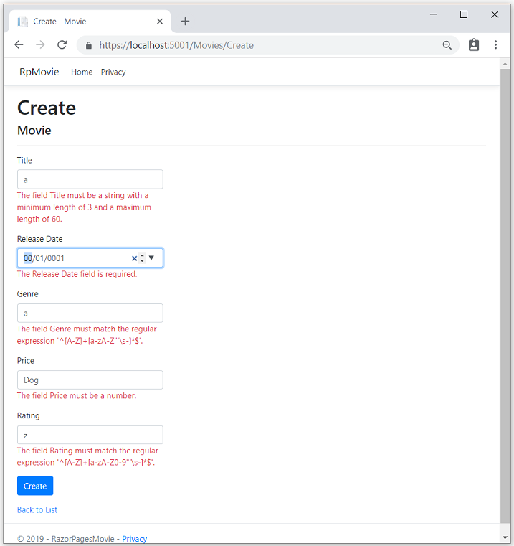
Note
You may not be able to enter decimal commas in decimal fields. To support jQuery validation for non-English locales that use a comma (",") for a decimal point, and non US-English date formats, you must take steps to globalize your app. This GitHub issue 4076 for instructions on adding decimal comma.
Notice how the form has automatically rendered a validation error message in each field containing an invalid value. The errors are enforced both client-side (using JavaScript and jQuery) and server-side (when a user has JavaScript disabled).
A significant benefit is that no code changes were necessary in the Create or Edit pages. Once DataAnnotations were applied to the model, the validation UI was enabled. The Razor Pages created in this tutorial automatically picked up the validation rules (using validation attributes on the properties of the Movie model class). Test validation using the Edit page, the same validation is applied.
The form data isn't posted to the server until there are no client-side validation errors. Verify form data isn't posted by one or more of the following approaches:
- Put a break point in the OnPostAsync method. Submit the form (select Create or Save). The break point is never hit.
- Use the Fiddler tool.
- Use the browser developer tools to monitor network traffic.

Server-side validation
When JavaScript is disabled in the browser, submitting the form with errors will post to the server.
Optional, test server-side validation:
- Disable JavaScript in the browser. You can do this using your browser's developer tools. If you can't disable JavaScript in the browser, try another browser.
- Set a break point in the OnPostAsync method of the Create or Edit page.
- Submit a form with validation errors.
- Verify the model state is invalid:
C#Copy
if (!ModelState.IsValid)
{
return Page();
}
The following code shows a portion of the Create.cshtml page that you scaffolded earlier in the tutorial. It's used by the Create and Edit pages to display the initial form and to redisplay the form in the event of an error.
CSHTMLCopy
<form method="post">
<div asp-validation-summary="ModelOnly" class="text-danger"></div>
<div class="form-group">
<label asp-for="Movie.Title" class="control-label"></label>
<input asp-for="Movie.Title" class="form-control" />
<span asp-validation-for="Movie.Title" class="text-danger"></span>
</div>
The Input Tag Helper uses the DataAnnotations attributes and produces HTML attributes needed for jQuery Validation on the client-side. The Validation Tag Helper displays validation errors. See Validation for more information.
The Create and Edit pages have no validation rules in them. The validation rules and the error strings are specified only in the Movie class. These validation rules are automatically applied to Razor Pages that edit the Movie model.
When validation logic needs to change, it's done only in the model. Validation is applied consistently throughout the application (validation logic is defined in one place). Validation in one place helps keep the code clean, and makes it easier to maintain and update.

Using DataType Attributes
Examine the Movie class. The System.ComponentModel.DataAnnotations namespace provides formatting attributes in addition to the built-in set of validation attributes. The DataType attribute is applied to the ReleaseDate and Price properties.
C#Copy
[Display(Name = "Release Date")]
[DataType(DataType.Date)]
public DateTime ReleaseDate { get; set; }

[Range(1, 100)]
[DataType(DataType.Currency)]
public decimal Price { get; set; }
The DataType attributes only provide hints for the view engine to format the data (and supplies attributes such as <a> for URL's and <a href="mailto:EmailAddress.com"> for email). Use the RegularExpressionattribute to validate the format of the data. The DataType attribute is used to specify a data type that's more specific than the database intrinsic type. DataType attributes are not validation attributes. In the sample application, only the date is displayed, without time.
The DataType Enumeration provides for many data types, such as Date, Time, PhoneNumber, Currency, EmailAddress, and more. The DataType attribute can also enable the application to automatically provide type-specific features. For example, a mailto: link can be created for DataType.EmailAddress. A date selector can be provided for DataType.Date in browsers that support HTML5. The DataType attributes emits HTML 5 data- (pronounced data dash) attributes that HTML 5 browsers consume. The DataType attributes do notprovide any validation.
DataType.Date doesn't specify the format of the date that's displayed. By default, the data field is displayed according to the default formats based on the server's CultureInfo.
The [Column(TypeName = "decimal(18, 2)")] data annotation is required so Entity Framework Core can correctly map Price to currency in the database. For more information, see Data Types.
The DisplayFormat attribute is used to explicitly specify the date format:
C#Copy
[DisplayFormat(DataFormatString = "{0:yyyy-MM-dd}", ApplyFormatInEditMode = true)]
public DateTime ReleaseDate { get; set; }
The ApplyFormatInEditMode setting specifies that the formatting should be applied when the value is displayed for editing. You might not want that behavior for some fields. For example, in currency values, you probably don't want the currency symbol in the edit UI.
The DisplayFormat attribute can be used by itself, but it's generally a good idea to use the DataTypeattribute. The DataType attribute conveys the semantics of the data as opposed to how to render it on a screen, and provides the following benefits that you don't get with DisplayFormat:
- The browser can enable HTML5 features (for example to show a calendar control, the locale-appropriate currency symbol, email links, etc.)
- By default, the browser will render data using the correct format based on your locale.
- The DataType attribute can enable the ASP.NET Core framework to choose the right field template to render the data. The DisplayFormat if used by itself uses the string template.
Note: jQuery validation doesn't work with the Range attribute and DateTime. For example, the following code will always display a client-side validation error, even when the date is in the specified range:
C#Copy
[Range(typeof(DateTime), "1/1/1966", "1/1/2020")]
It's generally not a good practice to compile hard dates in your models, so using the Range attribute and DateTime is discouraged.
The following code shows combining attributes on one line:
C#Copy
public class Movie
{
public int ID { get; set; }

[StringLength(60, MinimumLength = 3)]
public string Title { get; set; }

[Display(Name = "Release Date"), DataType(DataType.Date)]
public DateTime ReleaseDate { get; set; }

[RegularExpression(@"^[A-Z]+[a-zA-Z""'\s-]*$"), Required, StringLength(30)]
public string Genre { get; set; }

[Range(1, 100), DataType(DataType.Currency)]
[Column(TypeName = "decimal(18, 2)")]
public decimal Price { get; set; }

[RegularExpression(@"^[A-Z]+[a-zA-Z0-9""'\s-]*$"), StringLength(5)]
public string Rating { get; set; }
}
Get started with Razor Pages and EF Core shows advanced EF Core operations with Razor Pages.

Publish to Azure
For information on deploying to Azure, see Tutorial: Build an ASP.NET app in Azure with SQL Database. These instructions are for an ASP.NET app, not an ASP.NET Core app, but the steps are the same.
Thanks for completing this introduction to Razor Pages. We appreciate feedback. Get started with Razor Pages and EF Core is an excellent follow up to this tutorial.

Additional resources
- Tag Helpers in forms in ASP.NET Core
- Globalization and localization in ASP.NET Core
- Tag Helpers in ASP.NET Core
- Author Tag Helpers in ASP.NET Core

