Publish an ASP.NET Core app to Azure with Visual Studio
Source: https://docs.microsoft.com/en-us/aspnet/core/tutorials/publish-to-azure-webapp-using-vs

Important
ASP.NET Core preview releases with Azure App Service
ASP.NET Core preview releases aren't deployed to Azure App Service by default. To host an app that uses an ASP.NET Core preview release, see Deploy ASP.NET Core preview release to Azure App Service.
See Publish to Azure from Visual Studio for Mac if you are working on macOS.
To troubleshoot an App Service deployment issue, see Troubleshoot ASP.NET Core startup errors on Azure App Service.

Set up
- Open a free Azure account if you don't have one.

Create a web app
In the Visual Studio Start Page, select File > New > Project...
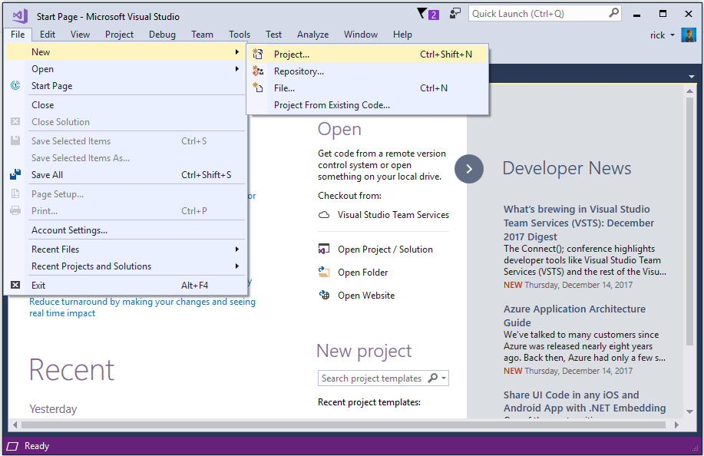
Complete the New Project dialog:
- In the left pane, select .NET Core.
- In the center pane, select ASP.NET Core Web Application.
- Select OK.
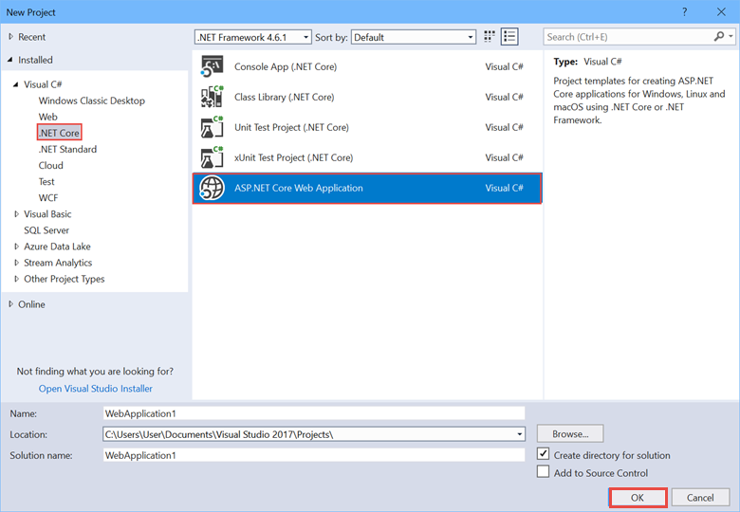
In the New ASP.NET Core Web Application dialog:
- Select Web Application.
- Select Change Authentication.
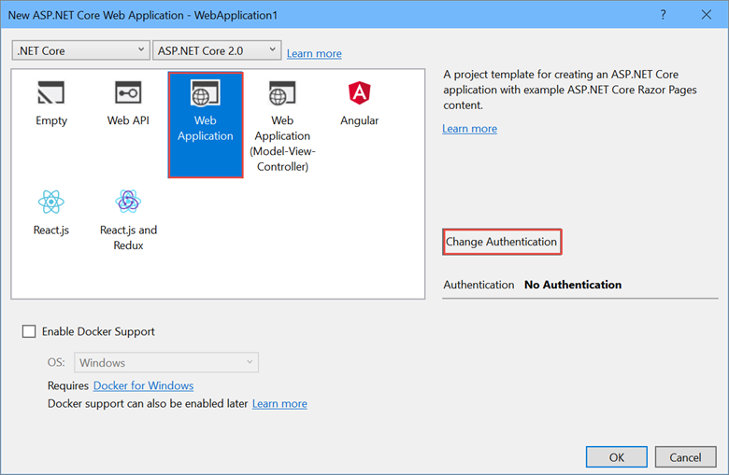
The Change Authentication dialog appears.
- Select Individual User Accounts.
- Select OK to return to the New ASP.NET Core Web Application, then select OK again.
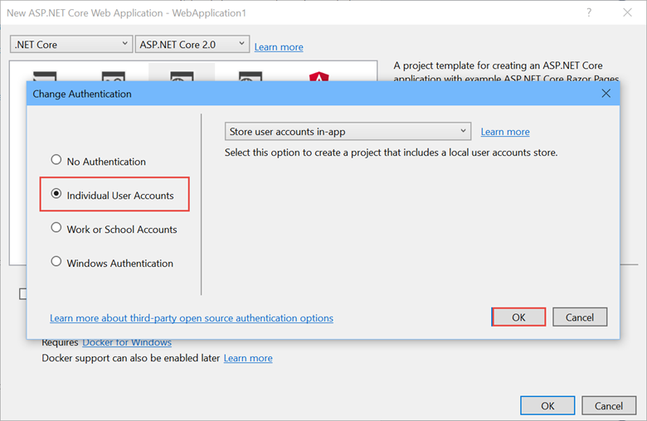
Visual Studio creates the solution.

Run the app
- Press CTRL+F5 to run the project.
- Test the About and Contact links.
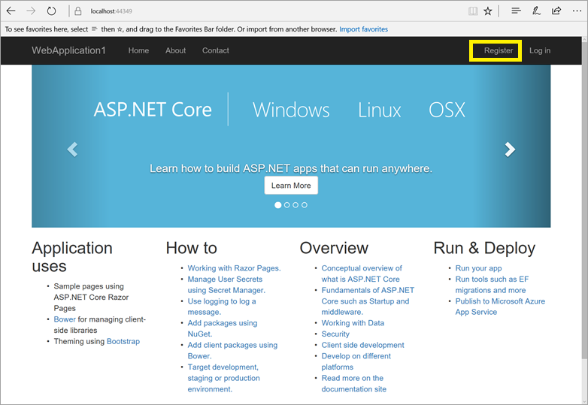

Register a user
- Select Register and register a new user. You can use a fictitious email address. When you submit, the page displays the following error:
"Internal Server Error: A database operation failed while processing the request. SQL exception: Cannot open the database. Applying existing migrations for Application DB context may resolve this issue."
- Select Apply Migrations and, once the page updates, refresh the page.
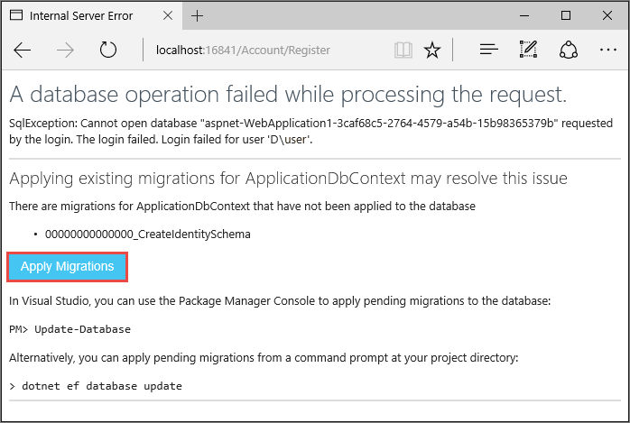
The app displays the email used to register the new user and a Log out link.
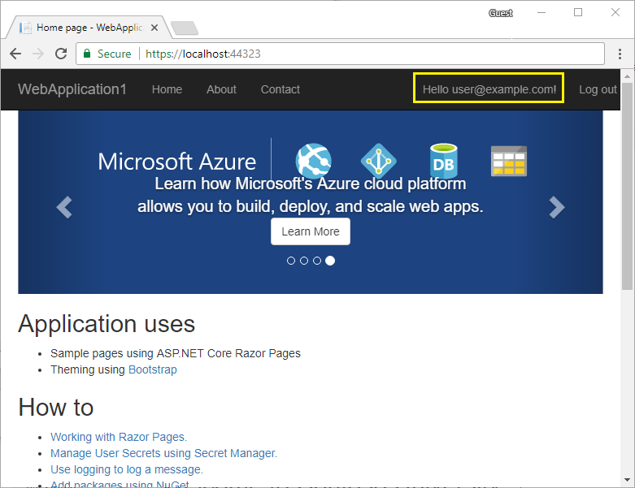

Deploy the app to Azure
Right-click on the project in Solution Explorer and select Publish....
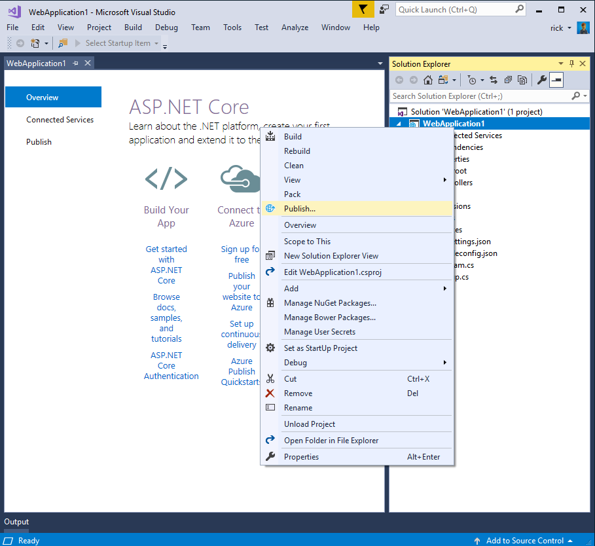
In the Publish dialog:
- Select Microsoft Azure App Service.
- Select the gear icon and then select Create Profile.
- Select Create Profile.
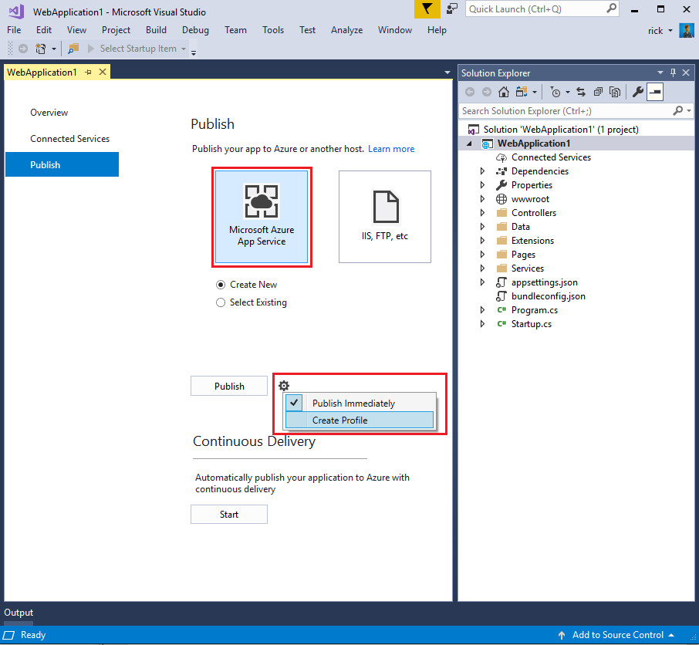

Create Azure resources
The Create App Service dialog appears:
- Enter your subscription.
- The App Name, Resource Group, and App Service Plan entry fields are populated. You can keep these names or change them.
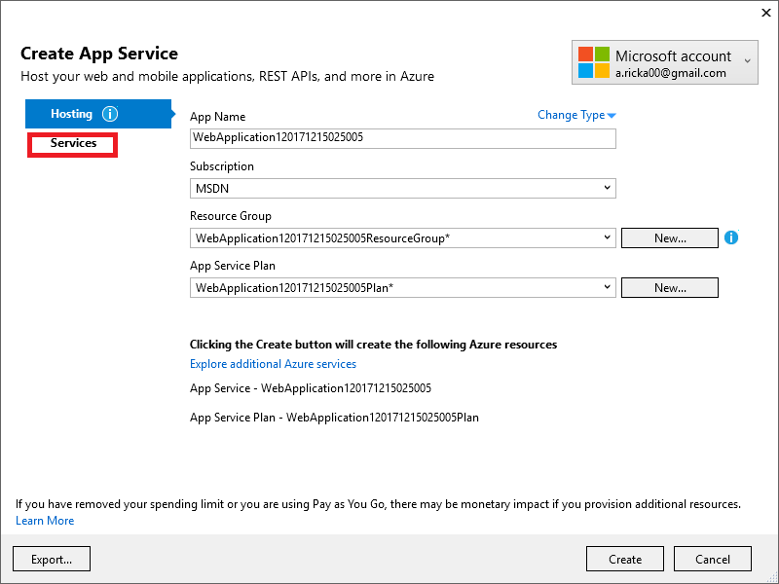
- Select the Services tab to create a new database.
- Select the green + icon to create a new SQL Database
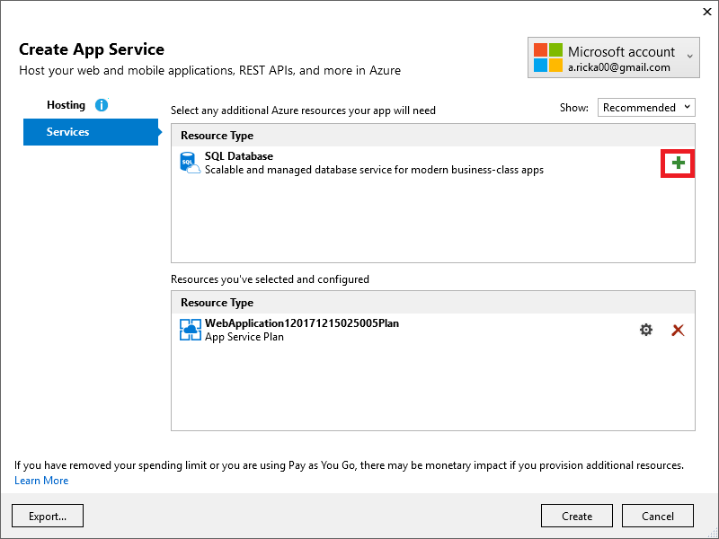
- Select New... on the Configure SQL Database dialog to create a new database.
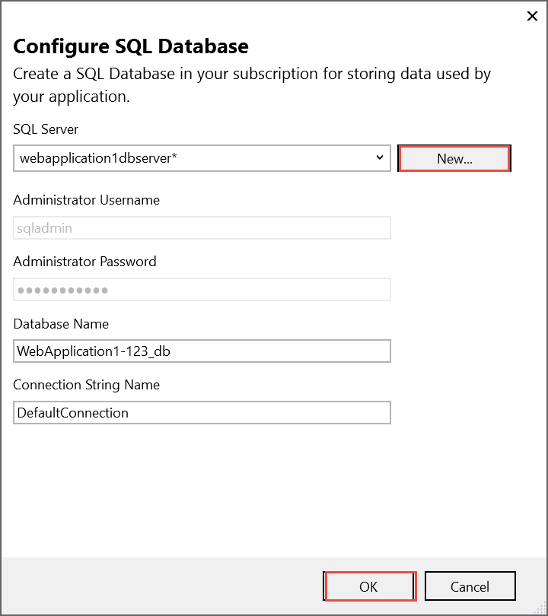
The Configure SQL Server dialog appears.
- Enter an administrator user name and password, and then select OK. You can keep the default Server Name.
Note
"admin" isn't allowed as the administrator user name.
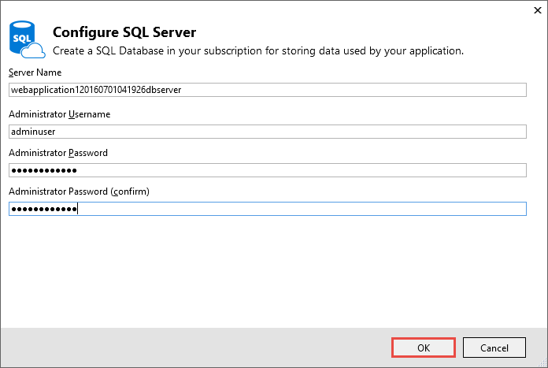
- Select OK.
Visual Studio returns to the Create App Service dialog.
- Select Create on the Create App Service dialog.
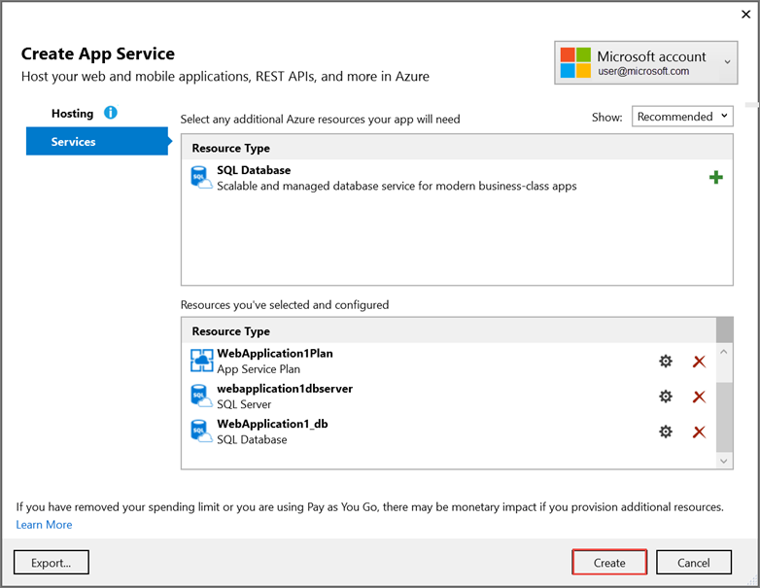
Visual Studio creates the Web app and SQL Server on Azure. This step can take a few minutes. For information on the resources created, see Additional resources.
When deployment completes, select Settings:
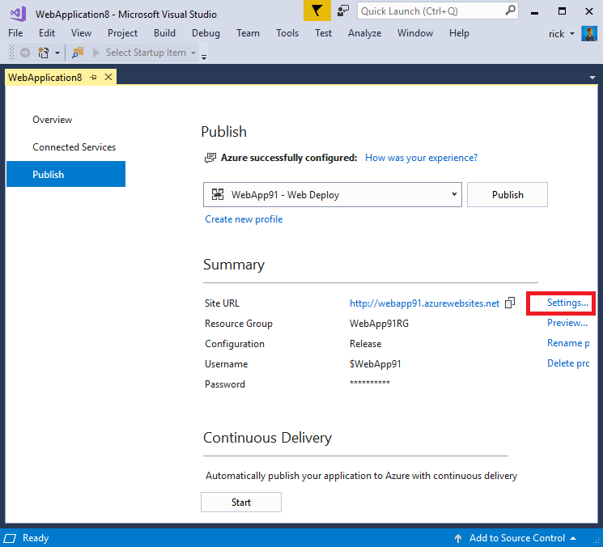
On the Settings page of the Publish dialog:
- Expand Databases and check Use this connection string at runtime.
- Expand Entity Framework Migrations and check Apply this migration on publish.
- Select Save. Visual Studio returns to the Publish dialog.
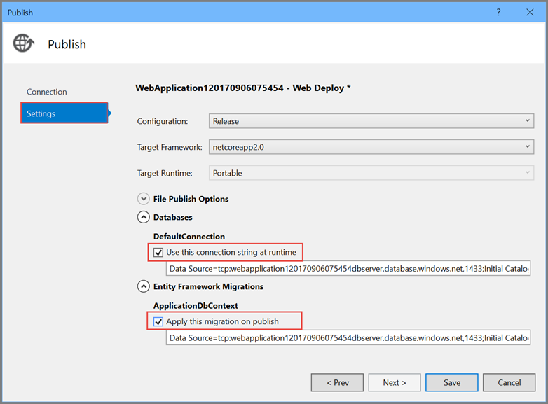
Click Publish. Visual Studio publishes your app to Azure. When the deployment completes, the app is opened in a browser.

Test your app in Azure
- Test the About and Contact links
- Register a new user
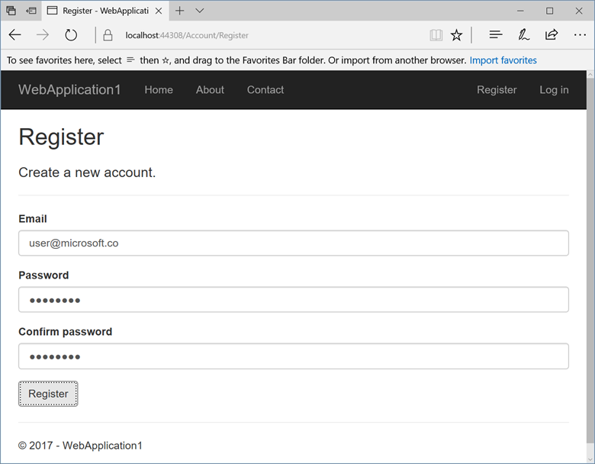

Update the app
- Edit the Pages/About.cshtml Razor page and change its contents. For example, you can modify the paragraph to say "Hello ASP.NET Core!":
HTMLCopy
@page
@model AboutModel
@{
ViewData["Title"] = "About";
}
<h2>@ViewData["Title"]</h2>
<h3>@Model.Message</h3>

<p>Hello ASP.NET Core!</p>
- Right-click on the project and select Publish... again.
- After the app is published, verify the changes you made are available on Azure.
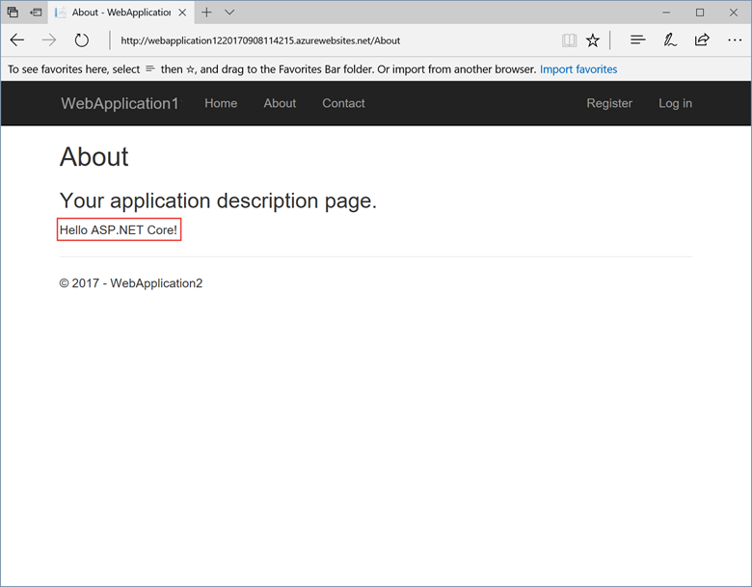

Clean up
When you have finished testing the app, go to the Azure portal and delete the app.
- Select Resource groups, then select the resource group you created.
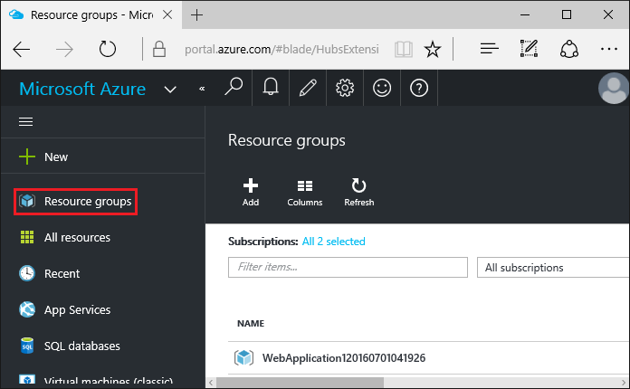
- In the Resource groups page, select Delete.
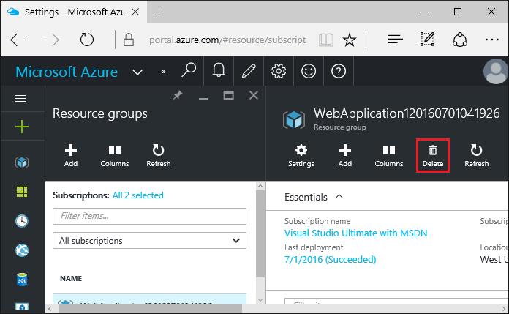
- Enter the name of the resource group and select Delete. Your app and all other resources created in this tutorial are now deleted from Azure.

Next steps
- Continuous deployment to Azure with Visual Studio and Git with ASP.NET Core

Additonal resources
- Azure App Service
- Azure resource groups
- Azure SQL Database
- Visual Studio publish profiles for ASP.NET Core app deployment
- Troubleshoot ASP.NET Core startup errors on Azure App Service

